Product Manual

Dc brushless barrier gate

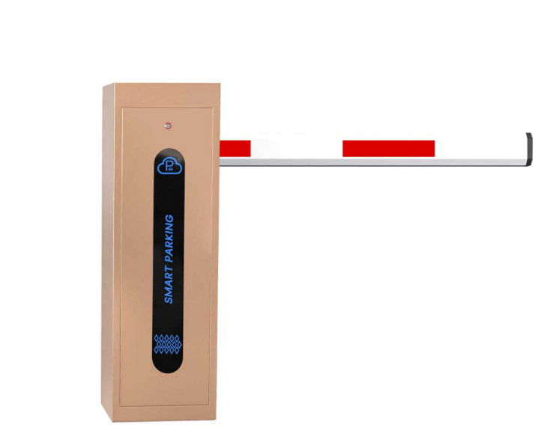

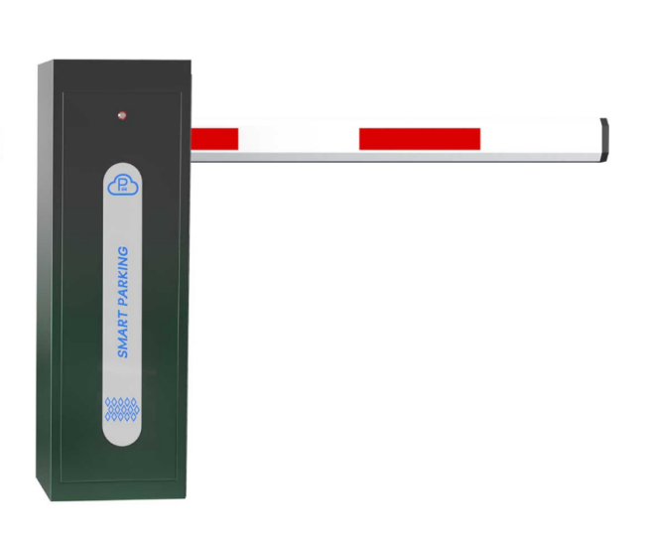

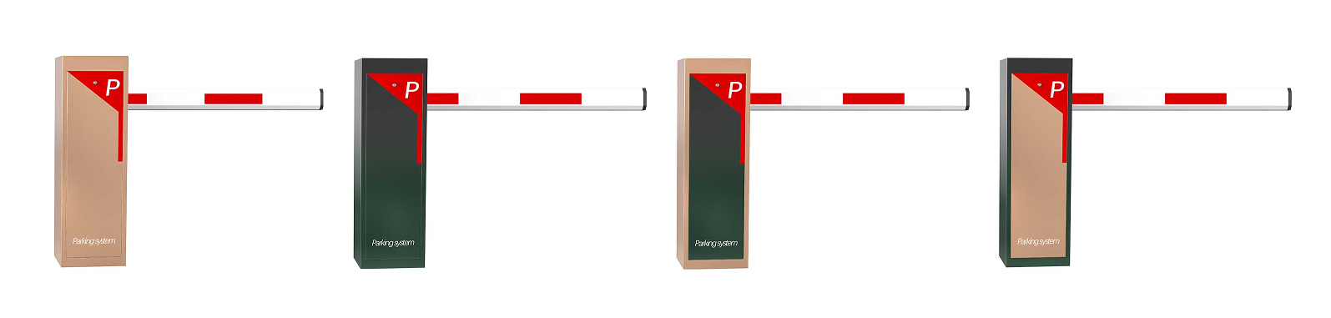



**01**

**02**

**Table of Contents**

1. Product performance

1、Mechanical characteristics…………………………3

2、Electrical characteristics……………………………3

3、Security feature………………………………………4

二、Product specifications and technical parameters 1、Controller parameters...........………………………5

2、Basic parameters of the motor……………………6

3、Terminal block definition………………………7、8

4、Internal structure of machinery………………………9

5、Installation dimensions of the controller…………10-11

6、Parameter debugging Settings………………………12

7、Wiring diagram…………………………………...........13

8、Common faults…………………………………........14

三、On-site installation instructions

1、Installation Instructions………………………........15

2、Specific operation………………………........16

四、Detailed menu description.............................17、18...24

五、Functional schematic diagram

1、Open area schematic diagram……………...............25

2、Schematic diagram of the key area…………...............26

六、Precautions…………………………………………...27

七、Product display……………………………………………28

# Product Introduction：

A controller that adopts brushless DC drive and integrates barrier gate function applications.

Equipped with DC brushless motor + barrier gate mechanism

The running speed is adjustable from 1.5 to 8 seconds

Product size: 310x245x990mm, 1.4 mm thick

Standard configuration: 2 remote controls, 4 expansion fixing screws

It is suitable for application scenarios such as residential communities, commercial properties, enterprises and institutions for vehicle entry and exit management.



**Product performance**

**Product performance**

**03**

**04**

● Supports standard remote control and intelligent learning functions, and supports 512 groups of remote control codes；

●It adopts original imported relays and can work stably in outdoor damp and complex environments；

●It integrates optical, electrical and mechanical control, is flexible and convenient to operate, and is safe and reliable to use；

● Status signal output function: Supports open position, closed position, and status dry contact output. The current status can be controlled and output by external light strips or indicator lights

● Communication interface: Supports RS232/RS485 serial port communication

● Startup and operation self-check function: The control can detect the operating status of the equipment and issue timely alarms

● Command control function: It can communicate with the upper computer through the serial port to realize the operation of the command control gate

This type of barrier gate is a new generation of intelligent barrier gate carefully designed by our company to adapt to modern "safe, fast, efficient and high-quality" management. Its high standards, high quality and high integration, as well as its fashionable and trendy appearance and unique visual charm, give people a sense of noble elegance and pleasing to the eye, making it even more complementary when paired with it. It is the first choice for supporting facilities in parking lots, hotels, schools, garden villa communities, enterprises and public institutions, etc.

1、Mechanical characteristics

●The chassis is sturdy and durable, waterproof,

and suitable for use in outdoor environments.；

● It adopts an integrated mechanism and is mass-produced with full molds, which greatly enhances the product stability and ensures the operational accuracy of the barrier gate.

●It adopts a precise four-bar linkage mechanism, enabling the barrier to run quickly and smoothly, effectively reducing the vibration of the barrier, easing the load on the motor, and extending the service life of the barrier；

3. Safety features

● Rebound upon obstruction: During the descent of the barrier, if it encounters an external force blocking, it will automatically lift, reducing the damage caused by errors.

● Ground sensor anti-crushing: During the descent of the barrier, if it receives a ground sensor signal, it will automatically lift the barrier. The barrier will not fall during the trigger period. Once the ground sensor signal is restored, the barrier will automatically fall to ensure safety.

● Priority anti-crushing for opening: During the descent of the barrier rod, if an emergency occurs, whether in the open or closed operation state, as long as the opening signal is received, the barrier rod will perform the opening action.

●It supports emergency stop and locking of the barrier halfway and self-locking in case of power failure

●DC servo motor, smooth transmission, low noise；

●Automatically lift the pole when there is a power outage,

which is convenient and fast ;

2、 Electrical characteristics

●The system is highly integrated and can be conveniently connected

to a variety of supporting devices；

●It adopts lifting timeout protection, effectively safeguarding the motor, allowing for all-weather operation and preventing abnormal damage to the turnstile；

● Rich status indicator light functions facilitate the use of

the equipment and after-sales maintenance；

**06**

**05**

******Product specifications and technical parameters**

**Product specifications and technical parameters**

1、Controller specification parameters 2、Basic performance parameters of the moto

|  |  |  |  |
| --- | --- | --- | --- |
| number | Project | Internal capacity | Reference Note |
| 1 | Rated voltage | 24ＶＤＣ |  |
| 2 | number of magnetic poles | 10 poles | 5 pairs |
| 3 | phase number | three phases |  |
| 4 | Hall | 120 degrees |  |
| 5 | Phase resistance | 1.1Ω |  |
| 6 | No-load speed | 2600RPM±%10 |  |
| 7 | no-load current | 1.75 A |  |
| 8 | Load speed | 1800RPM±%10 |  |
| 9 | load current | 4.16A |  |
| 10 | input power | 100-200W |  |
| 11 | Torque | 48N.m |  |
| 12 | Deceleration ratio | 1/150 | 3 to 6 seconds |
| 13 | Protection grade | IP20（GB4942.1） |  |
| 14 | Adaptation rod | ＜6mstraight rod |  |
| 15 | Insulation class | B |  |
| 16 | Ambient temperature | -30～+65℃ |  |
| 17 | service life | ＞one million times |  |

|  |  |
| --- | --- |
| Input voltage | 24V |
| Rated/peak current | 8A / 30A |
| Compatible motor | DC brushless motor |
| The compatible motor power | ≤200W |
| The human-machine interface features | 3-digit LED and 5-digit buttons |
| Communication interfaces | RS232/RS485 |
| Hardware protection | overcurrent protection, overvoltage protection and short-circuit protection |
| Input signals | open the gate, close the gate, stop, ground sensing, anti-crushing |
| output signal | the output signal fully open and fully closed |
| In case of power failure | open the switch and connect an external 12V 1AH battery |
| The temperature rise | ≤15℃ |
| The size of the controller | 176.6(H)*103(W)*34(D)mm |
| Working environment temperature | -20℃~55℃ |
| The working environment | 90%，no condensation |

1.1 Main Performance Description

The controller has three times the overload capacity and supports slow start and slow stop.

It can control the motor to achieve multi-level speed regulation, providing a wide range of speed adjustment. The speed range is 1 to 6 seconds.

The special control algorithm supports low speed and high torque, thus achieving smooth start and stop.

1.2 Main Characteristics

The 24-volt low-voltage DC barrier gate control system features a series of remarkable characteristics, making it perform outstandingly in terms of safety, functionality and convenience.

● Low-voltage DC 24 volts, no risk of electric shock when soaked in water, ensuring personal safety;

●3 times overload capacity and slow start and stop function;

The wechat mini-program enables remote control, fault reporting, and the application of special control algorithms.

● No motor thermal protection issue;

It is equipped with multi-level speed regulation function.

**Terminal block definition**

**Terminal block definition**

**07**

**08**

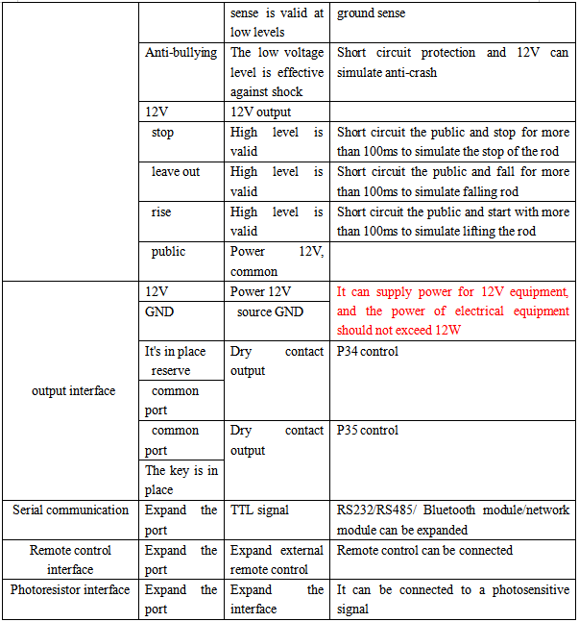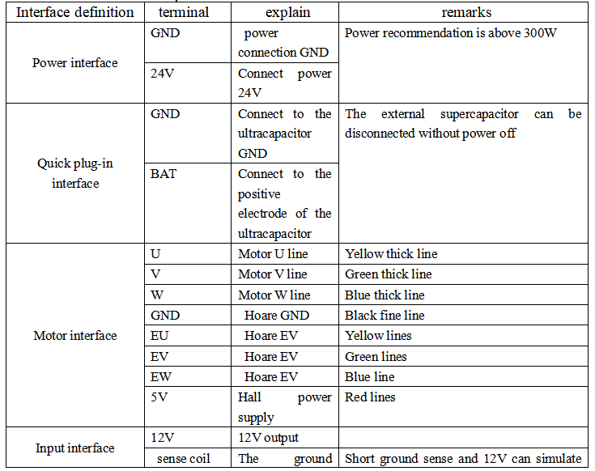

**Internal structure**

**10**

**Controller radar wiring diagram**

**09**

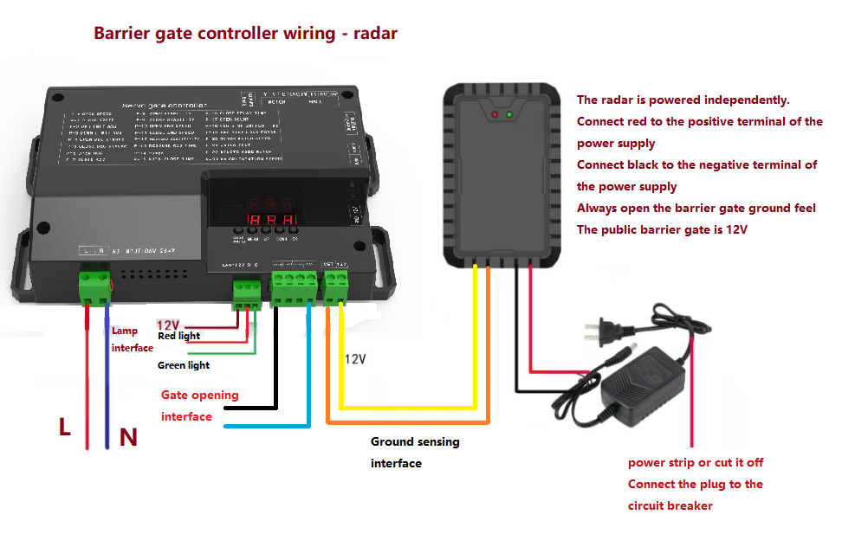

Movement shape, installation dimensions

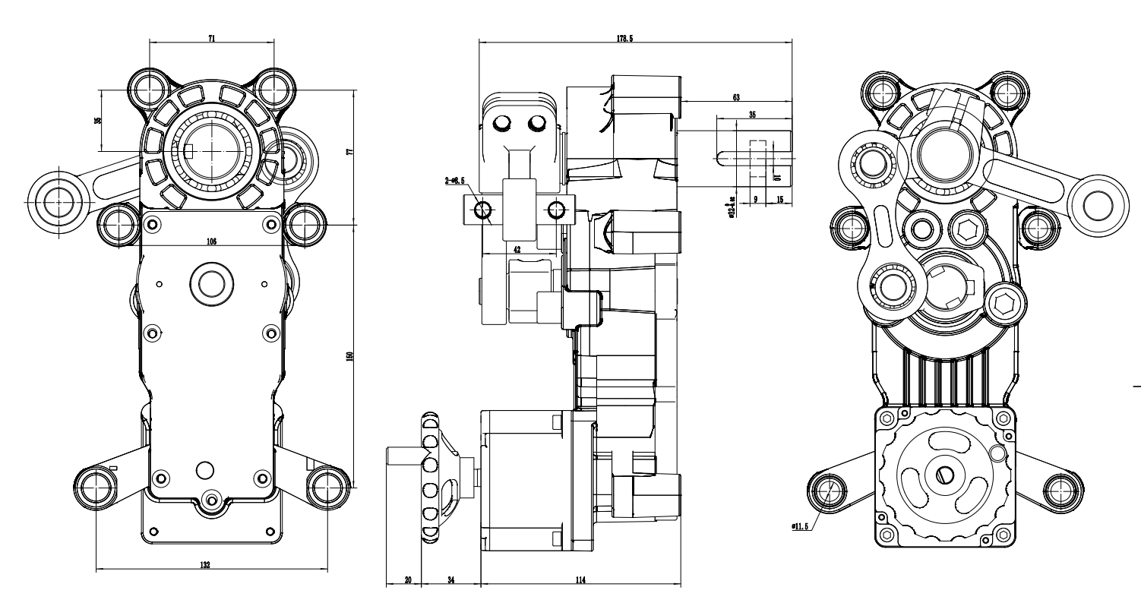

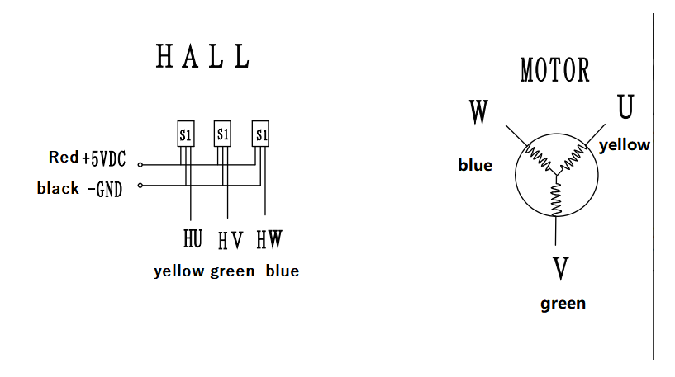

**Definition of the movement wiring**



**Installation dimensions of the controller**

**Parameter debugging Settings**

**12**

**11**

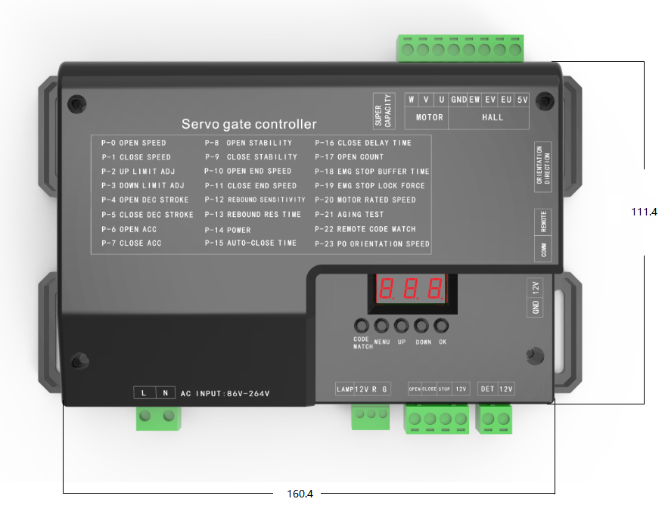

**Parameter Settings**

**First power on operation steps of the controller:**

1. **Check that the UVW wiring of the motor is ok, then power on. Press the "up" or "down" key on the motherboard. At this time, the motherboard will automatically find the zero. If the gate rod does not run in the direction of lifting the rod, turn the "zero direction" dial on the motherboard to the other side, and then power on again and find the zero again.**
2. **After finding the zero, the digital display will show around 90°. At this point, set the vertical and horizontal positions of the gate. Long press the 'menu' key to navigate to P-2, then short press the menu key. The digital display will show the 'value'. At this point, use the up and down keys to adjust the gate to the appropriate vertical position, then press the confirm key to exit. Repeat the process to enter menu P-3 and set the gate to the appropriate horizontal position.**

**6.1.1** **Parameter Settings**

**1. Instructions for menu setting**

1. [Software version interface]: The digital tube displays the program version number, such as V429, indicating that the soft version is D2-V428

A. At the beginning of power on, the digital tube displays the software version number for 1 second, and then displays [C parameter value]. After that, it needs to receive the gate opening/closing instruction to start the zeroing. After the zeroing is completed, it enters the normal operation interface.

2. [Normal operation interface]: The digital tube displays the gate running Angle.

A. Long press the "menu" key to enter the [Menu selection interface].

Note: After entering the parameter setting interface, if there is no key action for 30 seconds, the interface will directly return to the normal interface and save the parameters.

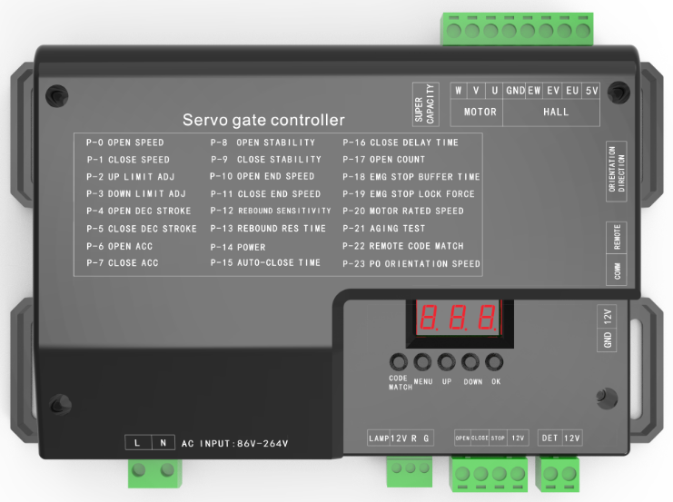

**14**

**Common faults**

**Wiring diagram**

**13**

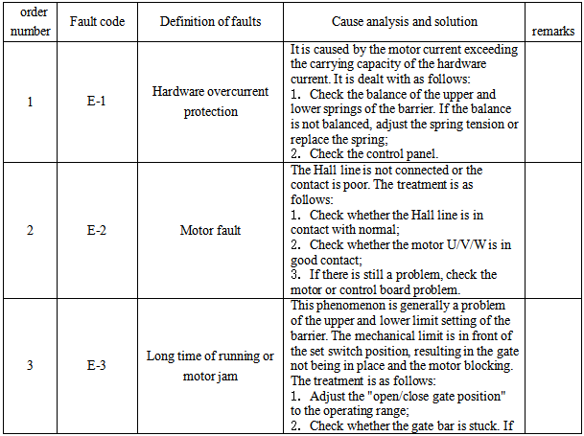

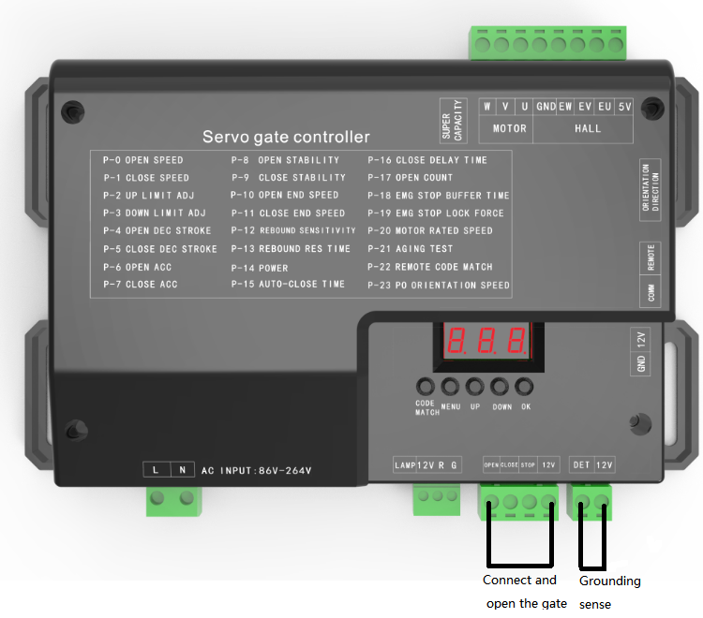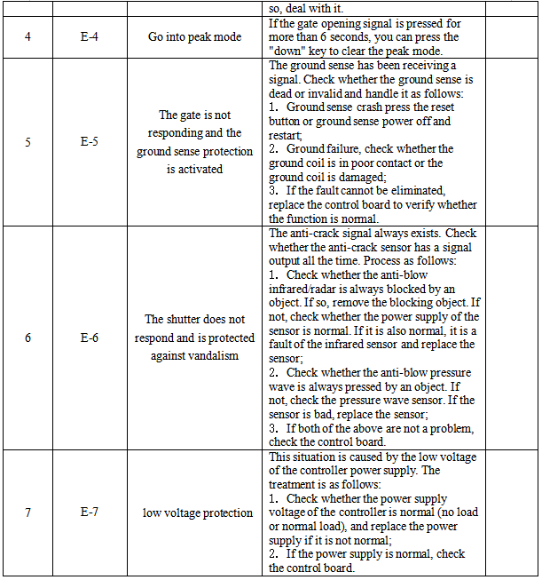

  **On-site installation instructions**

**On-site installation instructions**

**16**

**15**

(4) Installation of peripheral equipment

After the barrier gate is firmly installed and debugged, according to the customer's needs, the control circuits of the box and related peripheral devices can be connected according to the connection diagram of the barrier gate control board, and relevant debugging can be carried out.

(5) Installation of ground sensing

一 、Installation Instructions

●Open the packaging box and count the relevant random spare

parts according to the accessory list.

●The installation position of the barrier gate main unit should be determined based on the left and right direction of the selected barrier gate and the actual situation of the installation site. For non-concrete foundations or when the barrier gate main unit is installed on a slope, it is recommended to build a concrete foundation and ensure that the foundation is firmly combined with the base. The perpendicularity of the barrier gate main unit body to the horizontal plane should be less than 1˚.

200cm

●According to the location of the control room and the guard booth, power lines and control conduits should be laid in accordance with the relevant provisions of the "GB232 Code for Construction and Acceptance of Electrical Installation Works" (it is recommended that power lines and control lines be run through different conduits respectively).

●Install the expansion screws at the installation position of the barrier gate main unit (determined according to the actual accessories provided in the list), and fix the barrier gate main unit firmly before it can be used.

100cm

●Use the crank handle to shake the barrier to a horizontal position, determine the installation position of the end support rod of the barrier, and fix the support rod firmly with screws (no installation is required if there is no support rod).

●Carefully compare the wiring diagram, connect the power cord and related control lines to the control board of the turnstile, and after confirming that there are no errors, tighten and debug.

Ground induction coil

80 cm

Note: All the above operations should be carried out when the power is off.

二、Specific operation

1. First, draw the shape of the ground induction lines based on the on-site conditions. Generally, the width is 1000MM, and the length depends on the width of the road. Usually, the two ends are 700MM to 1000MM narrower than the road. At the four corners, make 45 #176 chamfering to prevent sharp corners from damaging the coil.

2. Use a road cutter to cut a groove on the road surface. The width of the groove is generally 3 to 5mm and the depth is 30mm. At the same time, a groove should also be cut for the coil lead wire to lead to the barrier gate.

3. Insert one end of the ground induction wire into the chassis and leave enough length. Then, start winding the coil along the cut groove. When winding the coil, it must be stretched straight, but not too tight and close to the bottom of the groove. Generally, it is wound five times. After winding, make the two wire ends out into a tightly twisted form and connect them to pins 7 and 8 of the vehicle detector.

4. After the coil is buried, connect the ground induction wire to terminals 7 and 8 of the ground induction base, plug in the ground induction plug and test it. During the test, pay attention to whether the power indicator light on the vehicle detector is constantly on, and whether the signal indicator light (green) is constant. When there is a vehicle in the detection area of the ground induction coil, the signal light is constantly on; when it leaves the detection area, the signal light flashes. When testing the lifting and lowering pole, observe whether the signal light is normal. If everything is normal, finally seal the cut groove with cement or asphalt.

(1) Pre-buried lines

According to the customer's requirements, the position of the chassis should be determined. If a concrete base needs to be poured, it can be completed in advance (the size of the base should be about 100-150mm larger than the external dimensions of the bottom of the barrier gate). Pre-bury or excavate cable trenches between the center point of the chassis's fixed position and the control room or guard booth, and lay out the conduits. After confirming that the 3* 1.5 square millimeter power line and 4* 0.5 square millimeter control line used for threading through the equipment are correct, backfill the concrete.

(2) Fix the chassis

Place the chassis in a fixed position, open the chassis door, and then make marks on the center of the

screw holes on the chassis bottom plate and the edge of the chassis base. Remove the barrier gate and

drill vertical holes at the marked positions with a drill bit (the size of the drill bit should match the expansion

bolts provided with the equipment), and the depth should meet the length requirements of the expansion

screws. Move the chassis back to its original position. Drive in the expansion screws and fix them firmly.

(3) Installation of the barrier

After the barrier gate box is firmly fixed, the barrier rod can be installed at the handle position, tightened with the provided screws, and made sure the barrier rod does not tilt. If a support rod needs to be installed, after adjusting the vertical and horizontal states, use the crank to turn the barrier rod to the horizontal position and determine the installation position of the support rod at the end of the barrier rod. Fix the support rod firmly with screws (no installation is required if there is no support rod).

**17**

**18**

**Detailed menu description**

******Detailed menu description**

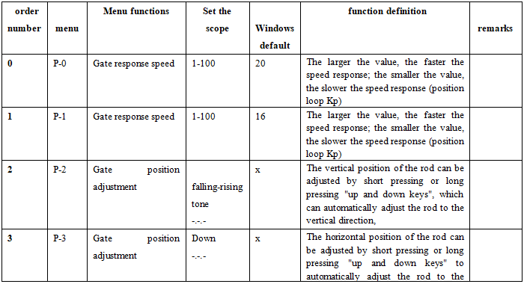

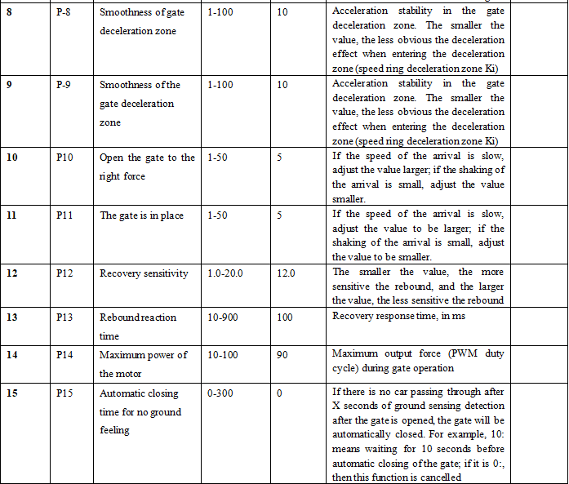

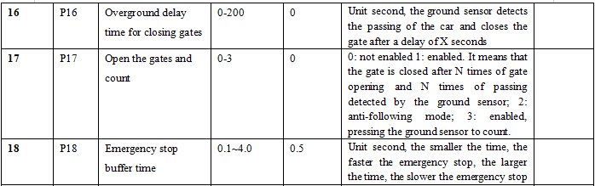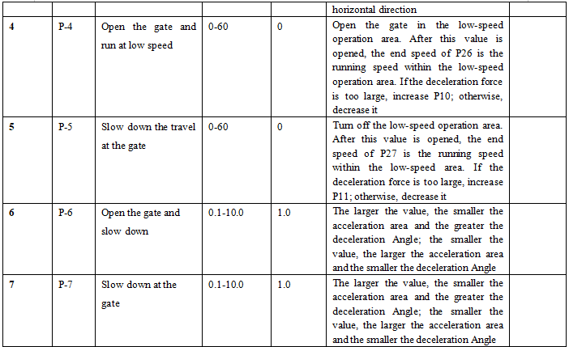

**20**

**19**

**Detailed menu description** 

 **Detailed menu description**

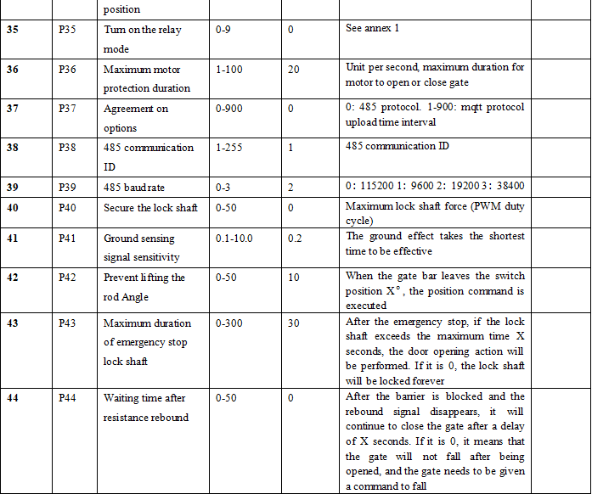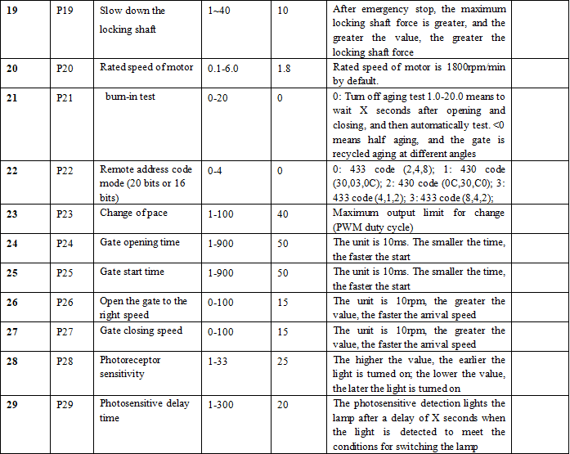

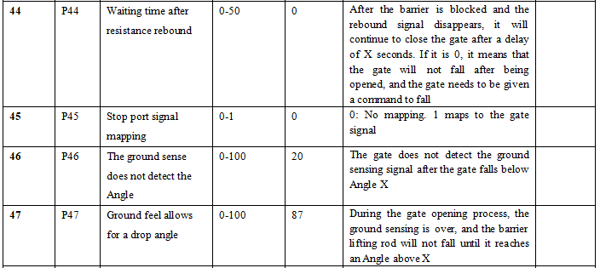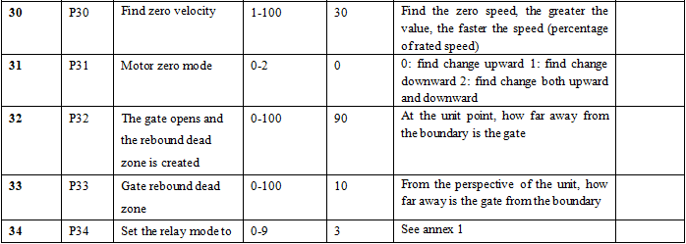

**22**

**Detailed menu description**

**Detailed menu description**

**21**

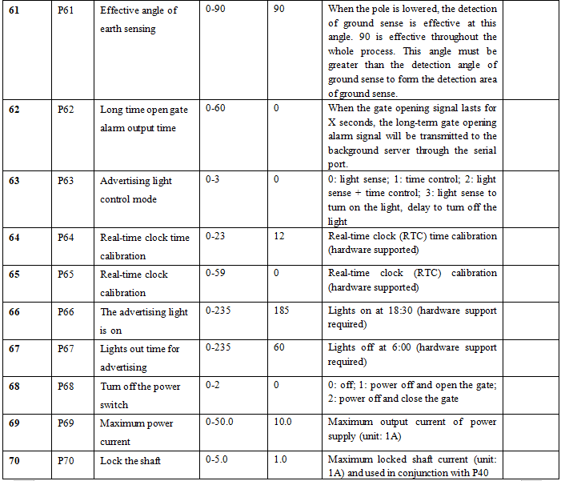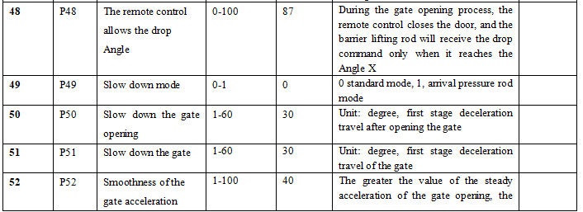

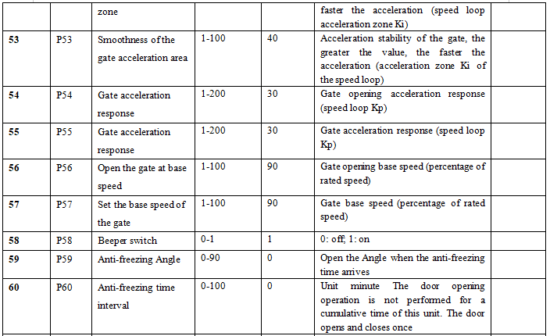

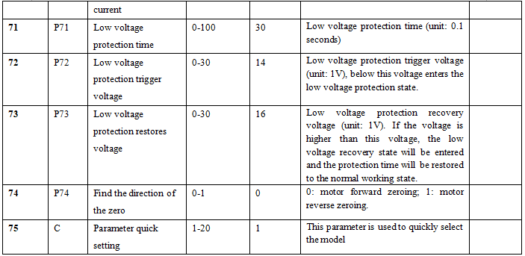

**24**

**Relay Mode Correspondence Table for On/Off Position**

**Relay Mode Correspondence Table for On/Off Position**

**23**

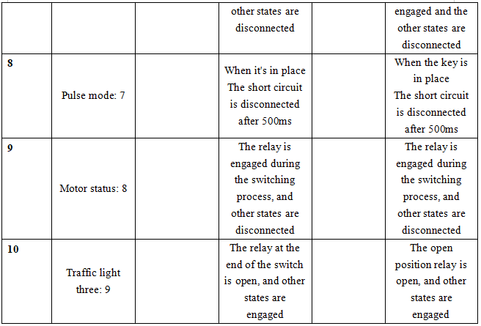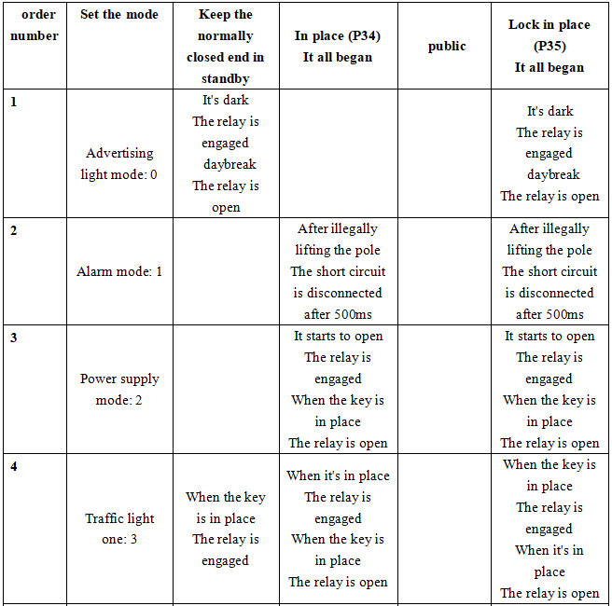

**Detailed menu description**

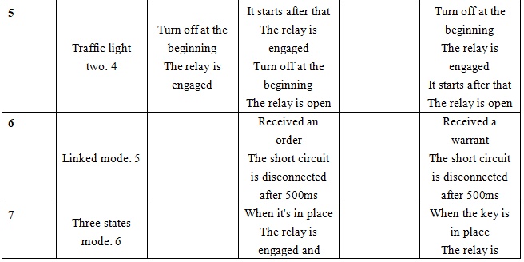

**Annex 2: Functional Schematic Diagram**

**Annex 2: Functional Schematic Diagram**

**26**

**25**

**Gate diagram**

1. **Schematic diagram of gate opening**

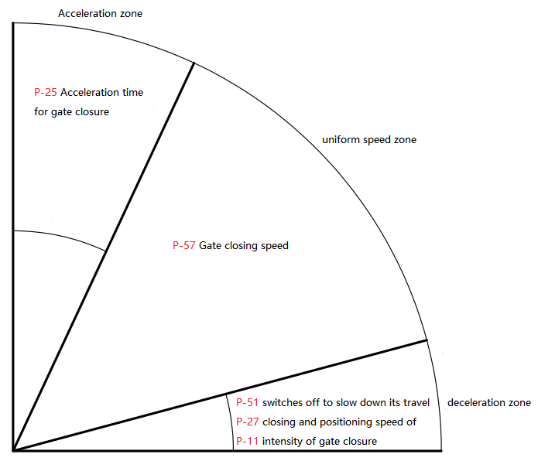

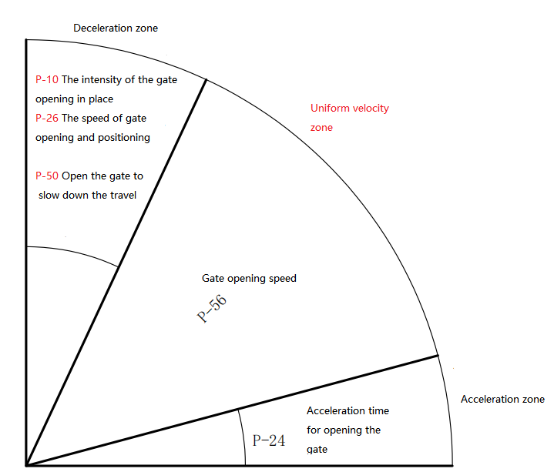

Schematic diagram of vertical and horizontal position Settings

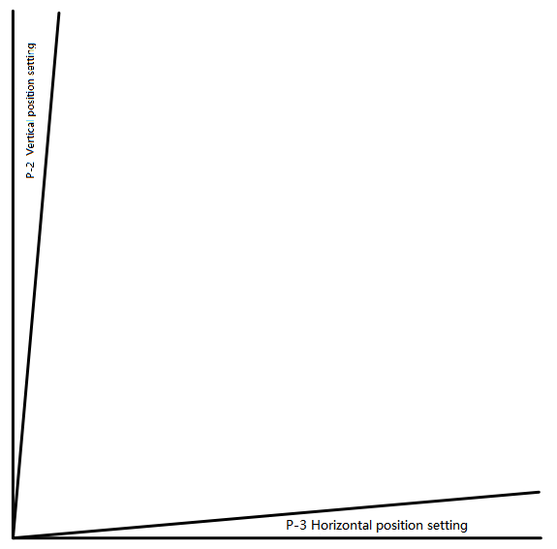

**28**

**Product display**

**27**

Safety Instructions:

Attention! Please read the manual before use and operate strictly in accordance with the requirements of the manual. 2. As packaging materials are potential sources of danger, they must be placed out of the reach of children. 3. Keep the instruction manual well for future use; 4. This product is strictly designed and manufactured in accordance with the user guide in the text file. Any use or operation that does not follow the instructions in the guide may cause product damage or pose a danger. 5. Our company shall not be held responsible for any adverse consequences resulting from improper use or use beyond the prescribed scope. 6. Do not install this product in areas with explosion hazards. Flammable gases are all serious safety hazards. 7. Mechanical parts must comply with relevant national standards; 8. The supporting products must be designed and manufactured in accordance with the requirements of the instruction manual. 9. Our company shall not be held responsible for any problems arising from the neglect of the process requirements of precision components or the deformation of these parts during construction. 10. Installation must comply with relevant national standards; 11. Before product maintenance, the power supply should be cut off. 12. Check whether the grounding is correct; 13. Safety devices (such as switches, sensors, etc.) should be protected from damage; 14. For supporting products not provided by our company, our company shall not be held responsible for any safety issues or failure to operate normally. 15. Repair only the original parts; 16. Do not make any changes to the components of this system; 17. The installer must provide the user with a detailed introduction to the operation prevention methods and relevant regulations in emergency situations, and offer the user an instruction manual. 18. When installing the product, children and other irrelevant personnel are strictly prohibited from approaching. 19. Keep the remote control out of the reach of children to prevent accidents from happening to them. 20. Anything not explicitly stipulated in the manual is not allowed.

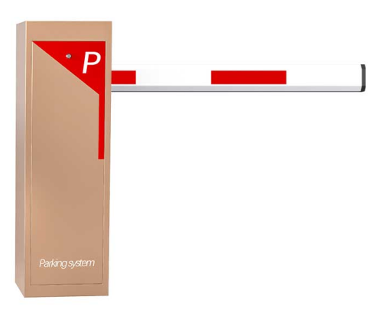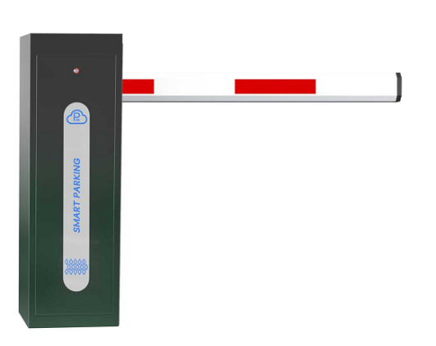

**Precautions for Use**

**Straight rod**

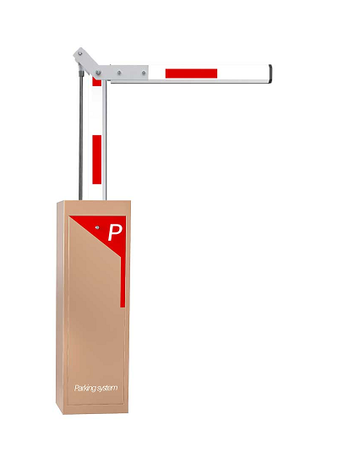

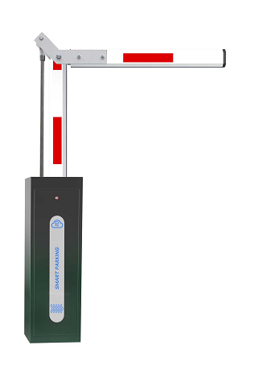

**Folding arm**

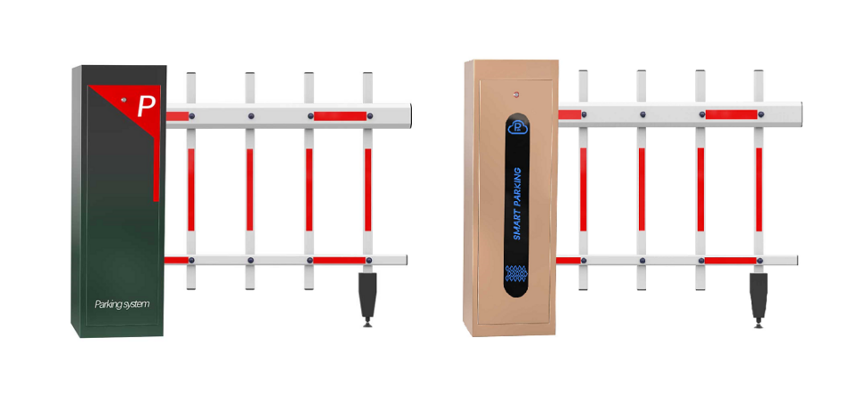

**Fence**